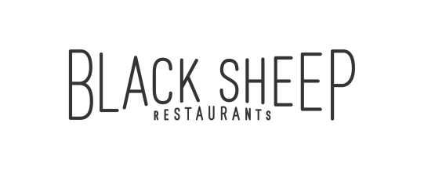

Black Sheep Restaurants is a Hong Kong-based hospitality group that specialises in developing niche, thought-provoking restaurant concepts that add to the existing culinary dialogue.

Whether recreating popular international concepts for the Hong Kong market or developing standalone restaurants, Black Sheep Restaurants curates distinct dining experiences that tell a story about a particular time, place, culture or cuisine while celebrating the bounty of premium ingredients available both locally and from abroad. The group currently boasts a portfolio of thirteen restaurants and bars, including Chôm Chôm, Motorino (Soho & Wan Chai), La Vache!, Ho Lee Fook, Carbone, Burger Circus, Stazione Novella, Le Garçon Saigon, BELON, Maison Libanaise, Buenos Aires Polo Club and Soul Food.

**FOOD RUNNER**

**ROLES & RESPONSIBILITIES**

* Deliver dishes with appropriate accompaniments and condiments from the kitchen to service stations / tables in the restaurant.
* Serve food and beverage in a highly professional manner
* Ensure the cleanliness of the restaurants

**REQUIREMENTS**

* With a pleasant service mindset and good attitude
* Ready to work hard, committed and be a good team player
* Good command in English would be an advantage
* Relevant experience in hotel/hospitality industry is an advantage

**BENEFITS**

* Competitive salary
* Quarterly discretional bonus
* Staff discount
* Daily staff meal
* Related training provided

Interested candidates please send their resume with **CURRENT and EXPECTED** salary to: [careers@blacksheeprestaurants.com](mailto:careers@blacksheeprestaurants.com) or contact our HR Team at 2810 0062 if you have any inquiries.

*(All personal information collected would be kept strictly confidential and for recruitment purposes only.)*